John Kiyak

CS 355

Homework 10

For this problem, we need to use the z test formula for proportions.

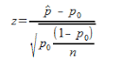

In our problem, we can insert 20 for N, .10 for **p̂, and .02 for p0.**

**Our equation then becomes:**

**Z = (.10 - .02) / √.02*(1-.02) / 20))**

**Z = (.10 - .02) / .031**

**Z = .08 / .031**

**Z = 2.58**

**After finding our Z variable, we look on the z table to find our value.**

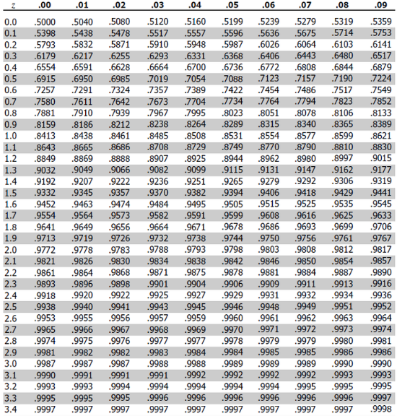

According to our z table, our value is .9951, which means that our p value is less than .05. That means that we can reject the null hypothesis and say that error rate is more than 2 percent. The error rate seems to be more than 2 percent, but less than 10 percent, so the customer is correct.